**Salesforce Rest API**

**For the invoke salesforce Rest API we must know the what are the token generating parametrs and what are the endpoint url’s used in salesforce restapi**

**Take token generating parametres as below for generate barear token.**

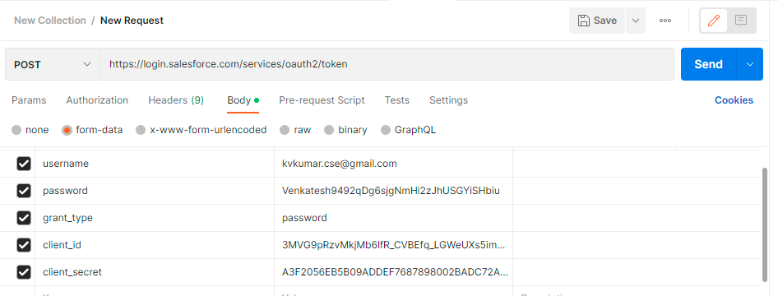

**After hitting of token we can get the barear token as below**

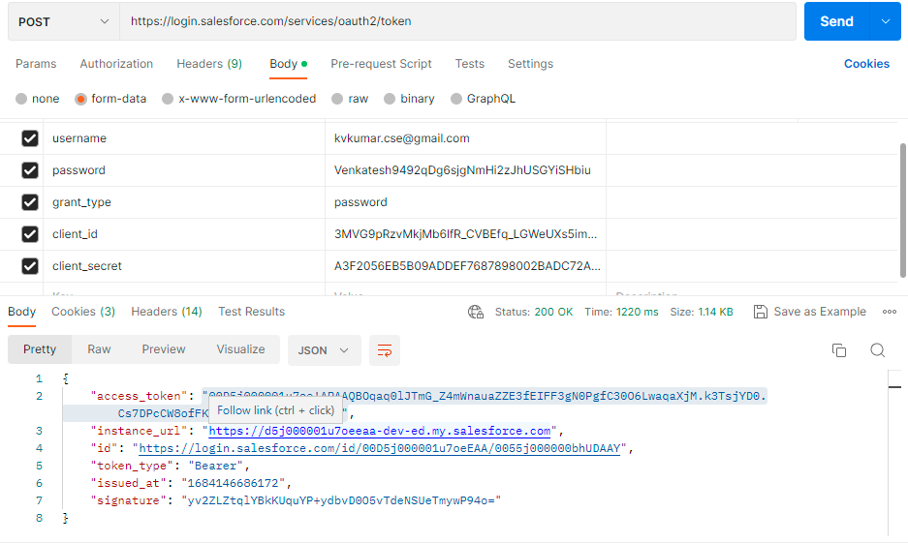

**Note:- Take post activity for generating token and check the case sensitive details .**

**Take the activities in the tibco bw6.x studio as below.**

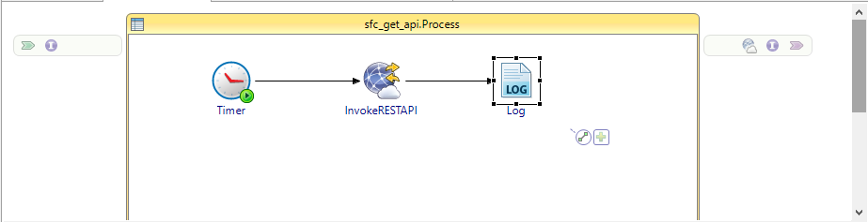

**Give the resource path and methods and request type and response type in the general tab as below.**

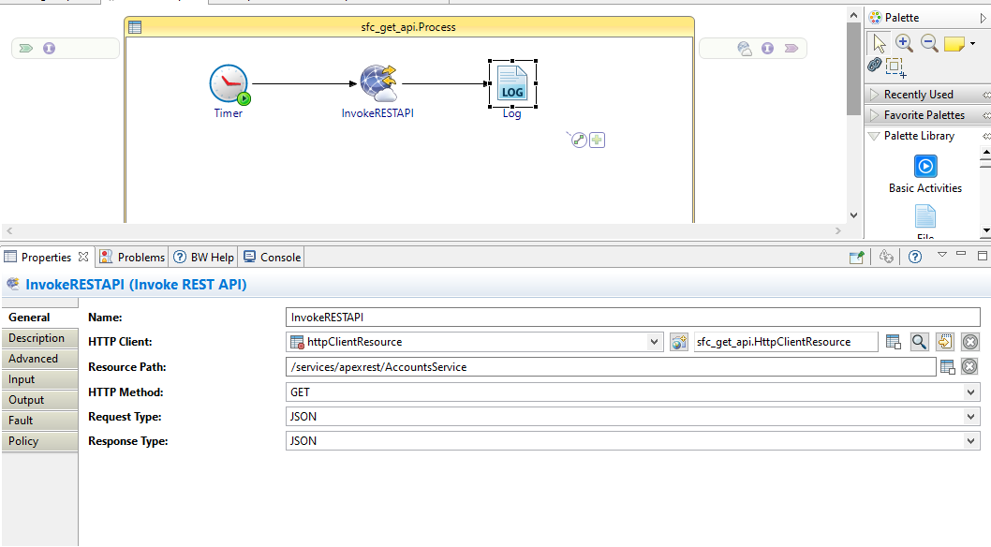

**Give the details in the resource tab as below.**

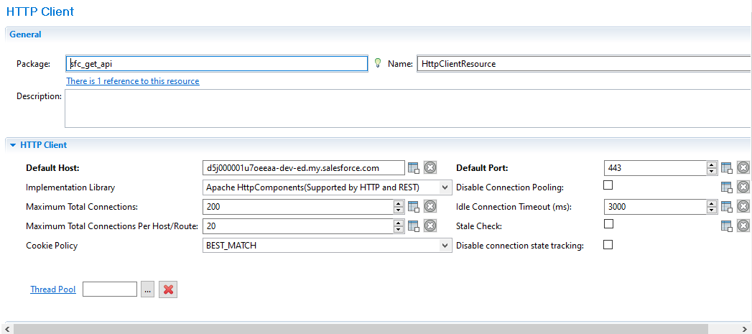

**Note:- check on default confidentiality.**

**I used 443 port because of above service is the external service.**

**Give the input details of invoke restapi as below.**

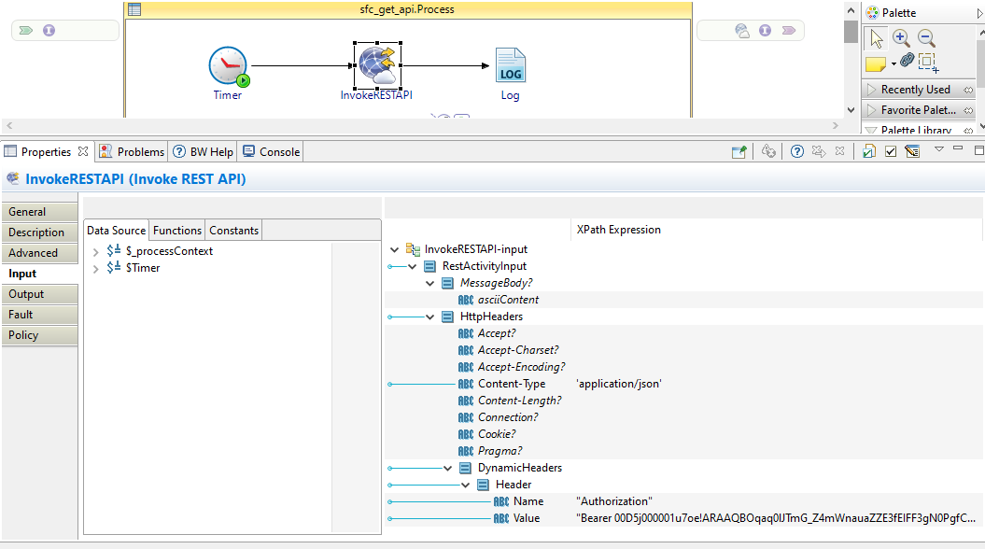

**And hit the service we can get the output of get operation (service output) output as below.**

